**Web Design and Development Foundations with HTML5**

**Hands-On Practice (HOP)**

HOP 4.1

HOP 4.2

HOP 4.3

HOP 4.4

HOP 4.5

HOP 4.6

HOP 4.7

HOP 4.8

HOP 4.9

HOP 4.10

HOP 4.11

HOP 4.12

HOP 4.13

HOP 4.14

HOP 4.15

HOP 4.16

Linear Gradient

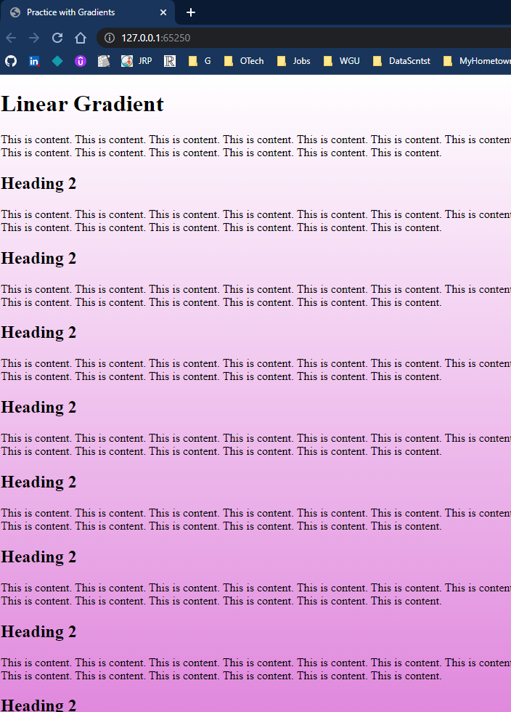

Radial Gradient

